Bahria University,

Karachi Campus



LAB EXPERIMENT NO.

**3**

LIST OF TASKS

|  |  |
| --- | --- |
| TASK NO | OBJECTIVE |
| 1 | **Display Product’s name and their supplier’s name (ContactName), whose supplier’s name does not contain Dirk and there should be at most 7 characters in Product’s name.** |
| 2 | **Create a report showing order ID. OrderDate. EmployeeID, and the firstname and LastName of the associated Employee (Tables: Employees & Orders).** |
| 3 | **List distinct cities from of customers and suppliers, country must be Germany.** |
| 4 | **List all cities (duplicate values allowed) from of customers and suppliers.** |
| 5 | **Lists all customers and suppliers (ContactName, City, Country).** |

Submitted On

**04/04/2022**

**Task 01: Display Product’s name and their supplier’s name (Contact Name), whose supplier’s name does not contain Dirk and there should be at most 7 characters in Product’s name.**

**Solution:** select productname from Products where productname like '_______' union select ContactName from Suppliers where not ContactName like '%Dirk%'

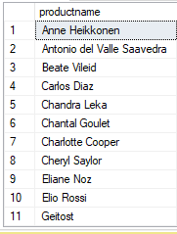**Output:**

**Task 02: Create a report showing order ID. Order Date. Employee ID, and the first name and Last Name of the associated Employee (Tables: Employees & Orders)**

**Solution:** select Orders.OrderId, Orders.OrderDate,Orders.EmployeeID,Employees.firstname,Employees.LastName from Orders inner join employees on orders.EmployeeID=Employees.EmployeeID

**Output:**

**Task 3: List distinct cities from of customers and suppliers, country must be Germany.  
  
Solution:** select city from customers where Country='Germany' union select city from Suppliers where Country='Germany'

**Output:**

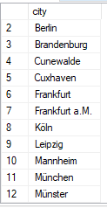  
**Task 4: List all cities (duplicate values allowed) from of customers and suppliers**  
**Solution:** select city from customers union all select city from Suppliers

**Output:  
  
Task 5:** **Lists all customers and suppliers (Contact Name, City, Country).**

**Solution:** select ContactName, City, Country from customers union select ContactName, City, Country from Suppliers

**Output:**